**“1 column, 2 item” email template documentation**

**Suggested software for updating HTML email templates**

Contact IT to get one of the following applications installed:

1. Dreamweaver – strongly recommended
   1. An Adobe product that requires a monthly payment
2. Notepad++
   1. Can be downloaded for free from: <http://notepad-plus-plus.org/>
3. TextWrangler
   1. Can be downloaded for free from: <http://www.barebones.com/products/textwrangler/>

**Ohio State brand guidelines for HTML/CSS emails**

Want to further customize your email? No problem! Use the sender’s information, unit identifiers, unit social media icons or unit-specific imagery to talk to your unique audiences. Keep these guidelines in mind:

* Use your college or unit name in text only at the top of an email.
* A logo or secondary signature may be used in the footer.
* Consider the length of the email, especially when read on a phone. Be brief.

**General dos and don'ts for HTML/CSS emails**

* **Don’t** use external style sheets.
* **Do** use inline style declarations for the most important styles.
* **Do** type out CSS styles in full, not shorthand. For example, type out font-style: italic; font-size: 12px; rather than font: italic 12px
* **Don’t** use divs, especially for multi-column layouts.
* **Do** use tables for multi-column layouts and “align-left” and “align-right” elements.
* **Don’t** change background colors on <td> inside <table> because it will cause hairlines to appear between the table cells on iOS devices.
* **Do** change background colors on <table>, if necessary.
* **Don’t** use local image paths.
* **Do** use absolute image paths. All images should be hosted on a server.
* **Do** use .jpg images, preferably less then 200KB.
* **Don’t** embed videos or iframes. **Avoid** animated .gifs.
* **Don’t** rely on images loading, especially background images.
* **Do** use as much “real text” as possible, rather than images. Important text should be typed or recreated in real text.
* **Do** include alt text descriptions of images, in case the user’s email client doesn’t download images automatically.
* **Don’t** use “em” for font-size and line-height. They are inconsistent among email clients.
* **Do** use “px” for font-size and line-height. This is the most consistent unit of measurement among all email clients.
* **Don’t** use traditional bullet points without inline styles.
* **Do** use <ul style="list-style-type:disc; padding-left:20px;"> or &bull; for traditional bullet points.
* **Do** link as many elements to a webpage as you can. Users may click or tap on a text link as well as an image, so it is best to link to something applicable.
* **Do** keep the HTML file size less than 100KB to prevent it from getting flagged as SPAM. This does not include image files sizes hosted on a server. Image file size does not have any impact on deliverability.
* **Avoid** overly image heavy emails without any supporting test. Emails that use a 60/40 text to image ratio should not be flagged as SPAM.
* **Avoid** lengthy emails. The longer the email, the slower the load time, especially on mobile devices. Furthermore, long emails are more likely to get deleted than light, small emails.
* **Do** test your email in multiple desktop, web-based and mobile device email clients. (See the “Email on Acid” section for more info on email testing.)

**Basic HTML commands**

Formatting content within an email requires a basic knowledge of HTML commands. Below are resources to help you code a clean and readable email:

[HTML basic commands](http://www.bios.niu.edu/johns/bioinform/htmlcom.html)

[HTML cheatsheet](http://www.webmonkey.com/2010/02/html_cheatsheet/)

**Getting started**

The HTML file is broken up with <!--START--> and <!--END--> comments. Pay attention to these when trying to delete or duplicate different pieces/parts (story blocks, events, social media icons, etc.). It is strongly encouraged to edit text within Dreamweaver’s “code view,”, rather than the “design view.”

**What to update**

**Preheader** (optional)

Use preheader text to enhance the value of the email content. Add a call to action, a short summary of your email or additional text to support the subject line.

* This is optional, but recommended to use.
* Ideal length of preheader text is 100-150 characters.
* The text is displayed in inbox previews of email clients, *before the message is opened*. The text is *hidden* in the opened message. See screenshots below of iPhone (left) and Android (right) inboxes.

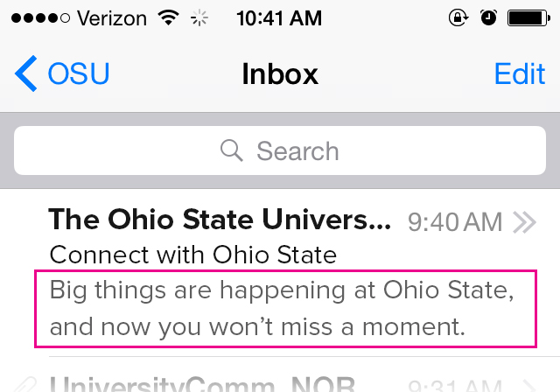 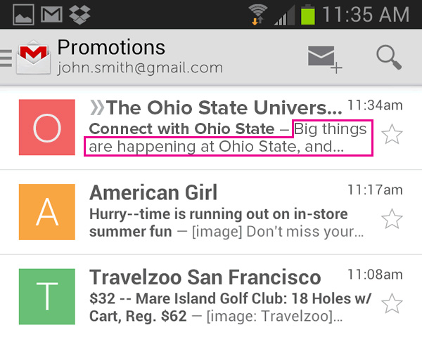

* By default, if the text is not updated, it will display “The Ohio State University.”
* Location in source code: <!--START preheader for previews in email clients -->

-----

**Body row**

**College or unit name**

* Location in source code: <!-- START unit name -->
* Tip: if the name of your college or unit is breaking in inappropriate locations, replace the spaces with “&nbsp;” – these are non-breaking spaces

**Date/Issue No.**

* Location in source code: <!-- START date -->

**Large header image**

* Location in source code: <!-- START large header image -->
* Suggested image size is 550x200px.

**Headline**

* Location in source code: <!-- START headline -->

**Body copy**

* Edit text in-between the opening <p> and closing paragraph tags </p>
  + EXAMPLE: <p style="font-family: Helvetica,Arial,sans-serif; font-size: 15px; line-height: 20px; color: #333333; margin-bottom:15px;">This is the text you will edit.</p>

**Text on button**

* Location in source code: <!-- START button -->

**Images**

* Location in source code: <!-- START small image, right aligned --> or <!-- START small image, left aligned -->
* Add an alt text description for each photo
  + EXAMPLE: <img src=”http://placehold.it/110x110” alt=”Department Chair John Doe” />

-----

**Double item row**

**Images**

* Location in source code: <!-- START double item image -->
* Suggested image size is 475x325px.
* Add an alt text description for each photo
  + EXAMPLE: <img src=”http://placehold.it/110x110” alt=”Department Chair John Doe” />

**Body copy**

* Location in source code: <!-- START double item text -->
* Edit the headline in-between the opening <h2> and closing heading tags </h2>
* Edit text in-between the opening <p> and closing paragraph tags </p>
  + EXAMPLE: <p style="font-family: Helvetica,Arial,sans-serif; font-size: 15px; line-height: 20px; color: #333333; margin-bottom:15px;">This is the text you will edit.</p>
* Tip: Use brief 1-2 sentences of a story. Then, link the headline, a few words in the text and/or the image to the full story that lives on your unit’s website.

-----

**Footer row**

**Logo** (optional to use official logo or [secondary logo](http://brand.osu.edu/secondary-signatures/))

* Location in source code: <!-- START logo -->
* For secondary logos, a max-width of 224px is recommended. The height will vary among all secondary logos.

**Contact information**

* Location in source code: <!-- START contact information -->
* As seen in the default code, wrap text in <span class="appleLinksDark"></span> to prevent a street address from becoming a blue link on Apple mobile devices.
* As seen in the default code, the link for an email address should be formatted as <mailto:emailaddress@osu.edu>

**Social media icons** (if using a secondary logo, it is recommended to use college or unit specific icons)

* Location in source code: <!-- START college or unit social media -->
* Update URLs on all buttons, add buttons or delete buttons
* To delete an icon, remove the code in-between the START and END comments.
* To add an icon, copy code from another icon from START to END comments, then paste the code above or below that original code. Then, change the image source for the new icon and update the alt text description. *Be sure to keep “&nbsp;&nbsp;” in-between each icon to ensure spacing.*
* Change the image source to the file names below when adding or changing unit icons.
  + Facebook:

http://osu.edu/assets/web/email/assets/socialicons/facebook-lightgray@2x.png

* + Flickr:

http://osu.edu/assets/web/email/assets/socialicons/flickr-lightgray@2x.png

* + Google Plus:

http://osu.edu/assets/web/email/assets/socialicons/googleplus-lightgray@2x.png

* + Instagram:

http://osu.edu/assets/web/email/assets/socialicons/instagram-lightgray@2x.png

* + LinkedIn:

http://osu.edu/assets/web/email/assets/socialicons/linkedin-lightgray@2x.png

* + Pinterest:

http://osu.edu/assets/web/email/assets/socialicons/pinterest-lightgray@2x.png

* + RSS:

http://osu.edu/assets/web/email/assets/socialicons/rss-lightgray@2x.png

* + Twitter:

http://osu.edu/assets/web/email/assets/socialicons/twitter-lightgray@2x.png

* + YouTube:

http://osu.edu/assets/web/email/assets/socialicons/youtube-lightgray@2x.png

* Ohio State social media icons and links do not need to be updated.

**Preferences (Unsubscribe | Privacy Policy Links)**

* Location in source code: <!-- START preferences -->
* Update the “Unsubscribe” link with your unit-specific communication preference page from the list of special links in BBIS.

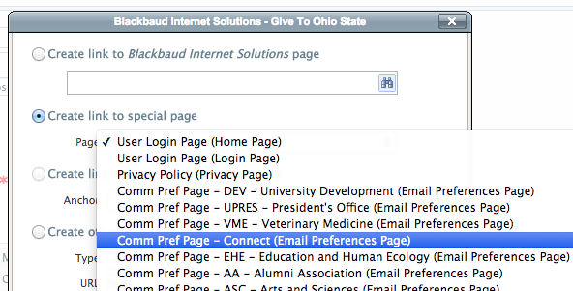

* Privacy Policy does not need to be updated, as it is already linked to the single [privacy policy page](https://connect1.osu.edu/page.aspx?pid=203) shared by the university.

**Email on Acid**

This tool allows for design preview across multiple desktop and mobile email clients, information on deliverability and advanced analytics. Email [broadcast@osu.edu](mailto:broadcast@osu.edu) to claim an account for your unit. Note that access is contingent upon usage of the BBIS email system and participation in the Broadcast Email Community. You must also submit a [shared email address](https://docs.google.com/forms/d/1XYFaFMnKiqrRQVq7P4t_ssActAkZ39Qf8kJBxCYoLq4/viewform) for your unit, accessible by those on your team who will use [Email on Acid](https://www.emailonacid.com/login).